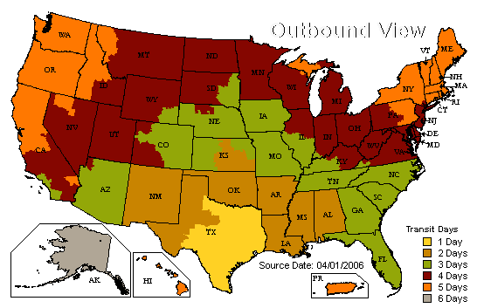

How long does it take my order to travel UPS ground to me?
The chart above will help you calculate when to expect your package
on UPS Ground shipments from The Mayron Cole Music Conservatory,
Inc. Travel days DO NOT include the day that the package is shipped.
They DO NOT include Saturday & Sunday. They DO NOT include
National Holidays.
Exactly when will my package be delivered?

UPS Ground packages are delivered to residential addresses Monday through Friday between 9:00 a.m. and 7:00 p.m., and to business addresses during their normal business hours Monday through Friday. UPS Ground packages cannot be scheduled to arrive at a specific time of day. UPS express shipments have guaranteed delivery times that vary by service.

Why wasn't my package delivered in three days, as indicated?

"Three days" means three “business days” (three “travel days”). This does not count the day that the package is picked up by UPS at our warehouse. Please note that the UPS Service Guarantee applies only to business days, and excludes weekends, holidays, and other events that may occur.

